**Delivery App Set-up Document**

1. **How to Open Project in Android Studio**

**\*** Click on File on the top left corner and Open the folder or file where you stored or saved the project file and then Select the project to test it.

**\*** **Path Example**-Go to File < open < F:\Techmania project/GreenZoneGogrocerSetup < DeliveryBoy-App < Press Ok.

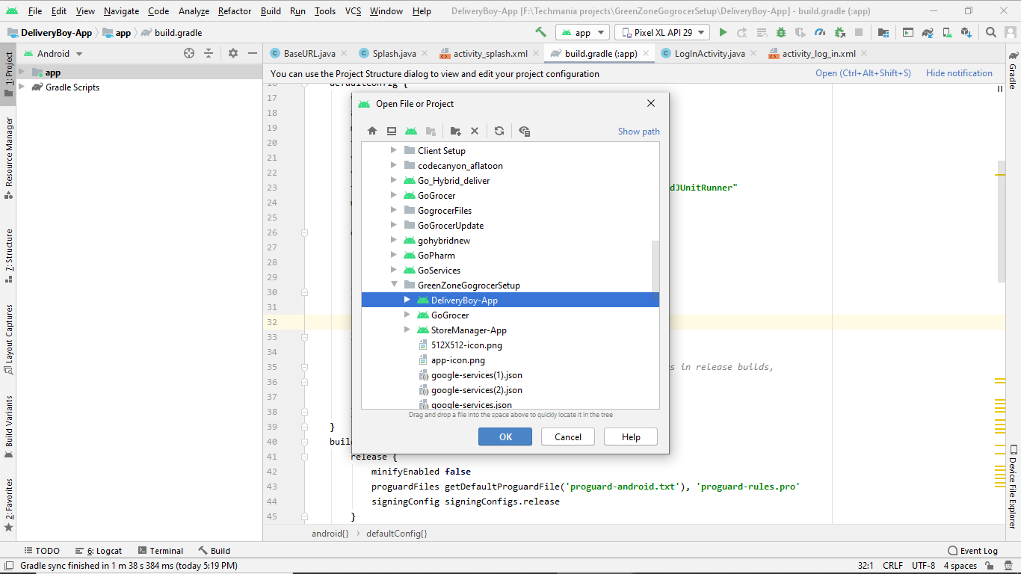

**2. How to change Logo or App Icon**

**\*** Click on app on left corner, then click on res folder, there will be drawable folder inside res folder.

**\*** Then Select the drawable folder and paste your own icon with logo.png. (Make sure your icon name must be same as used in project. Ex- In app, logo name is logo.png)

**\* Path** - Go to app < select res < select drawable folder and paste your icon < logo.png

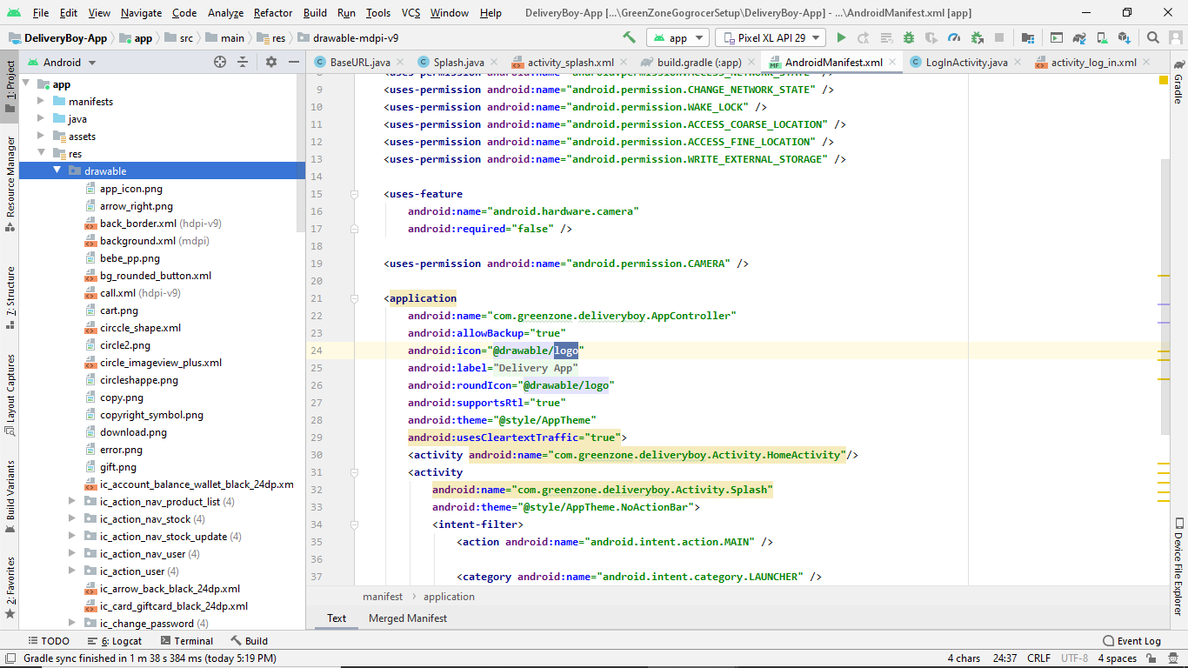

**3. How** **to change the Color in your App**

**\*** To change the color in app, Go to app, then open res folder and select values folder. There must be color.xml file, you have to open this file to change the colors in your app and here you can set your own color.

**\* Path -** Go toapp < select res < select values < open color.xml

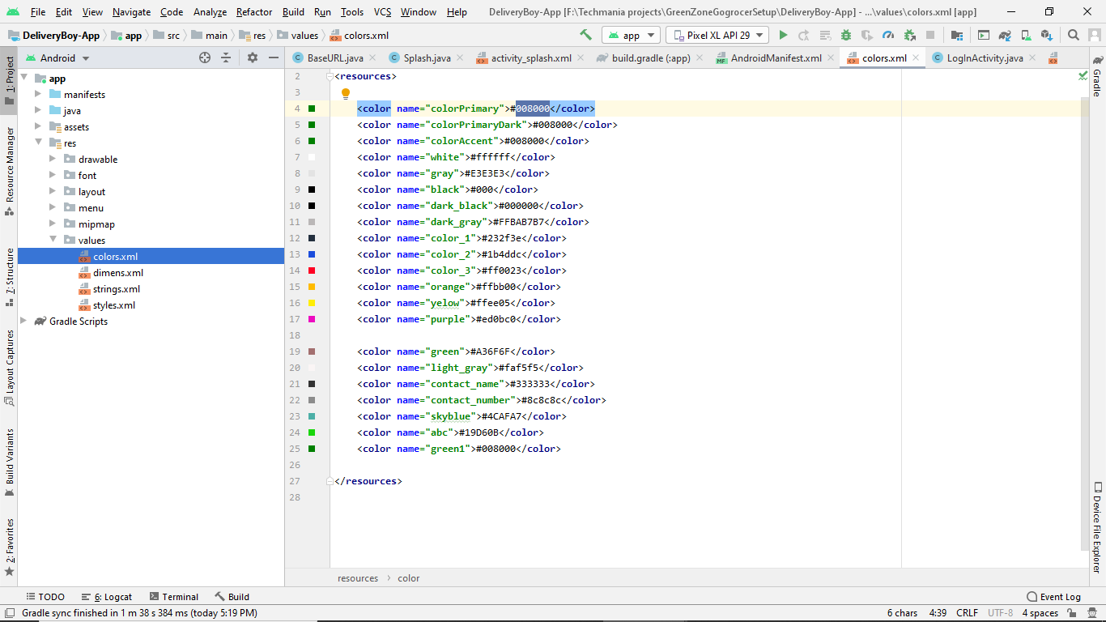

**4. How to change Base Url -**

**\*** To change a base url in your app, you must go to app and then select and open java folder ,here you have to select com.godeliver.user.After that you can see Config folder, you should click on it to open BaseUrl folder and here you can use your own base url.

**\* Path-** Go to app < select java folder < select com.godeliver.user < select Config folder < open BaseUrl folder < replace your BASE_URL.

(Note- Do your changes inside the comas = “ ”; and make sure api you added here “ ” must be in small letters.)

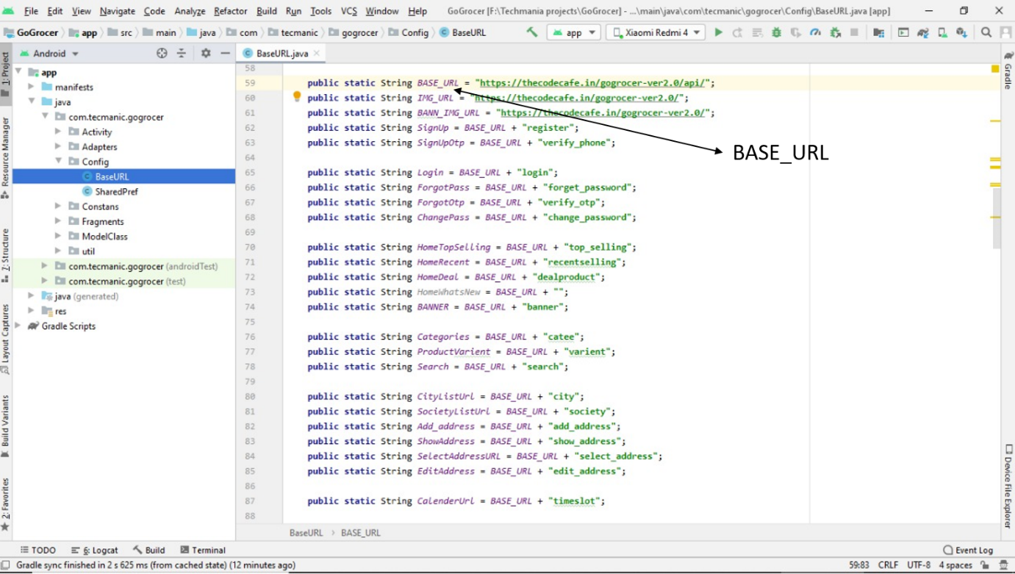

**5. How to change the App Name**

**\*** Inside app folder, select res folder and then values folder and do open strings.xml file to change your app name.

**\* Path-** Go to app < select res < select values folder < open strings.xml file <do change in <string name= “app_name”>***your app name***</string>

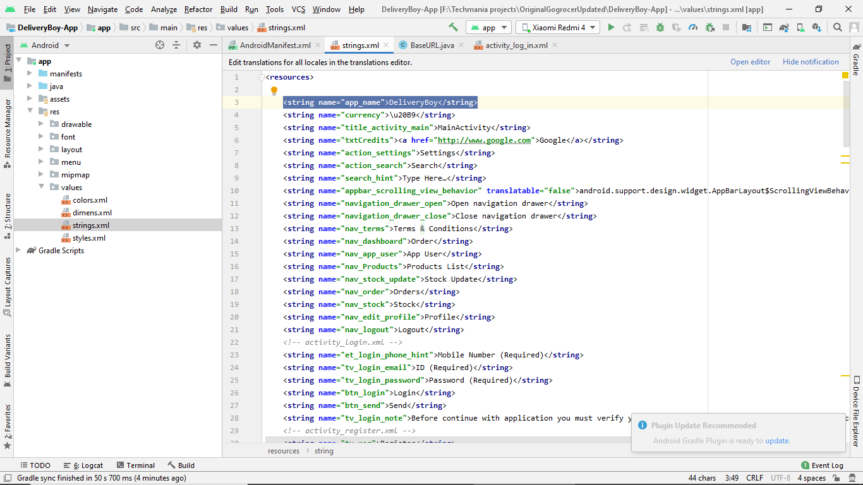

**6. How to change the Package Name**

**\*** Go to Gradile Scripts and select and open build.gradile (Module: app), now here you should change your package name with your own package name. For example applicationId “your package name” , as you can see in the image given below.

**\* Path-** Go to Gradile Scripts < select and open build.gradile(Module: app)

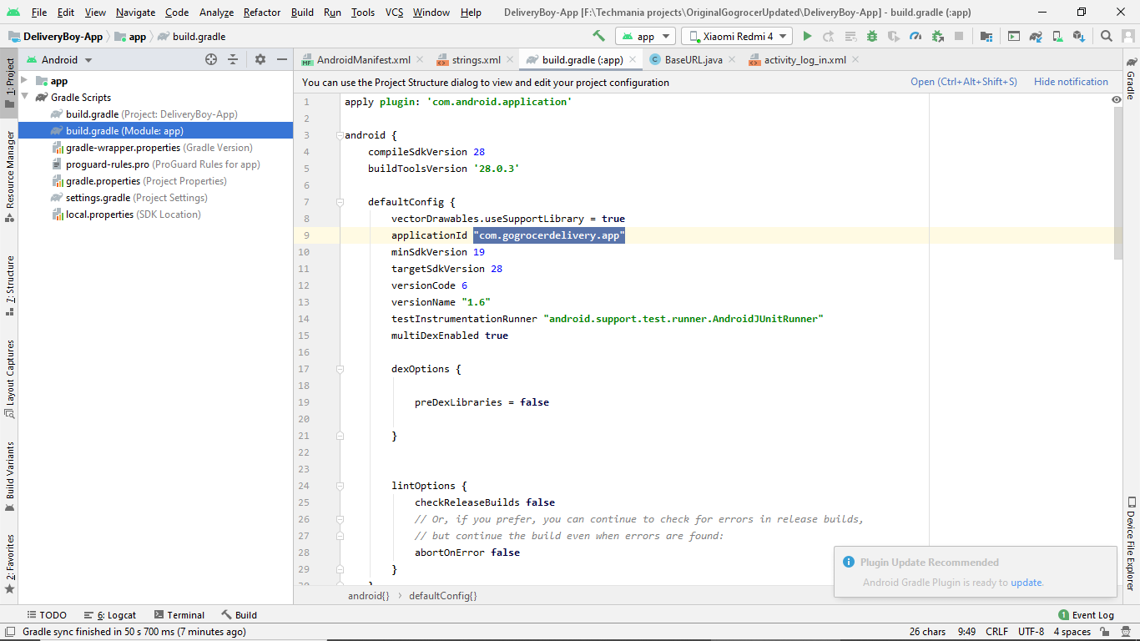

**7. Connect to firebase**

**\*** Go to Project and open app folder and paste and replace your google-services.json file here.

*Go to firebase console < create project < select android < go to authentication < sign up method < email and phone no enabled and save < go to docs < add project package name and SHA 1 no. < add dependency < download json service file.

